Application of Neural Networks and Genetic Algorithms in Optimization Model for Flower Base Layout

Abstract: Given the continuous growth in demand for ornamental flowers, flower bases are facing the dual challenge of scientifically planning planting layouts to enhance both aesthetic value and economic benefits. This study aims to develop an optimization model for flower base layout by combining neural networks and genetic algorithms to address this need. By collecting and analyzing flower planting data, the input parameters of the model were defined, and corresponding neural network structures and genetic algorithm processes were designed to optimize flower layout. Experimental results show that the optimized flower base significantly improves its aesthetic value, achieves noticeable economic growth, and enhances visitor satisfaction. This research not only validates the effectiveness of the proposed model but also provides a new perspective and tool for flower base management, promoting the application of scientific management methods in the field of horticulture and facilitating the sustainable development of flower bases.

Keywords: Flower base layout optimization; Neural networks; Genetic algorithms; Aesthetic value; Economic benefits; Visitor satisfaction

# Introduction

As unique places connecting natural beauty with human aesthetic, flower bases have increasingly demonstrated their economic and social value in recent years, driven by the growing pursuit of high-quality living. Against this backdrop, enhancing the aesthetic value and economic benefits of flower bases effectively has become a crucial research direction in the fields of horticultural science and landscape design[1]. Traditional layout optimization methods often rely on empirical judgment, lacking precise data support and struggling to adapt to the rapid changes in market demand. Therefore, this study introduces an optimization model combining neural networks and genetic algorithms, aiming to provide quantitative optimization solutions for flower base layouts through scientific algorithms[2]. By deeply analyzing current market trends and challenges faced by flower bases, this paper explores the innovative application of technology in traditional horticultural fields, with the aim of providing new ideas and methods for the sustainable development of flower bases.

# Theoretical Foundations

## Neural Network Theory

Neural network theory and genetic algorithms, as two innovative technologies in the current technological field, demonstrate unique advantages in solving complex problems. Derived from the working principles of biological neural networks, neural networks simulate the mechanism of information processing in the human brain, constructing a network system with a large number of interconnected neurons capable of self-learning and self-adjustment[3]. The essence of this theory lies in its ability to recognize patterns and relationships implicit in data, enabling neural networks to demonstrate powerful practical application capabilities in processing large-scale datasets, identifying complex patterns, and solving nonlinear problems. With the advancement of computing technology and algorithm optimization, neural networks have evolved from theoretical research products into core technologies driving the development of artificial intelligence, with their application ranging across many fields such as language processing and image recognition, becoming an indispensable part of modern technology. The introduction of genetic algorithms further expands the application boundaries of neural networks, providing an efficient method for finding global optimal solutions by simulating natural selection and genetic mechanisms in biological evolution. This algorithm not only enhances the ability of neural networks to solve specific problems but also provides researchers with a new perspective to understand and explore the essence of complex problems[4].

## Overview of Genetic Algorithms

Genetic algorithms, as efficient search algorithms, draw inspiration from the mechanisms of selection, crossover, and mutation in nature, effectively simulating the process of biological evolution to find the optimal solution to a problem. The core idea of this algorithm originates from Darwin's theory of natural selection, continuously generating candidates for solutions and evaluating and selecting these candidates using a fitness function, choosing the best-performing individuals to enter the next generation. Through multiple iterations, the algorithm gradually approaches or reaches the optimal solution[5].

For the objective function max(f(x,y)), a mapping relationship with the fitness function fitness(x,y) can be established through the following transformation:

For the objective function min(f(x, y)), a mapping relationship with the fitness function fitness(x,y) can be established through the following transformation:

where Cmin and Cmax are adjustable parameters, and the fitness function fitness(x,y) should always be greater than 0.

Its notable feature lies in its excellent global search capability, especially when facing optimization problems with vast solution spaces and high complexity. Genetic algorithms can effectively find satisfactory solutions in a unique way. Due to its flexibility in design and simplicity in parameter adjustment, this algorithm has been widely applied in various fields such as engineering optimization, scheduling problem solving, and machine learning, demonstrating enormous potential in solving various complex optimization problems. Genetic algorithms not only provide a new tool for scientific research but also demonstrate their powerful functionality in practical applications[5]. By simulating the wisdom of biological evolution, they provide a new approach for humans to solve complex problems, promoting technological progress and industrial development.

# Building of Flower Base Layout Optimization Model

## Problem Definition and Model Assumptions

In the research on optimizing flower base layout, the main problems and assumptions were first clarified to construct a clear research framework, aiming to explore how to scientifically plan flower planting to maximize both aesthetic value and economic benefits. The flower planting areas set in this study are rectangular in shape, which helps simplify the complexity of the problem, making the construction and optimization of the model more efficient[6]. Considering that different types of flowers have varying growth cycles, space requirements, and economic values, the model needs to flexibly handle these differences and propose reasonable layout plans accordingly. To ensure the scientific rationality of flower layout, the model also needs to consider the reasonable distribution of visitor flow and the growth requirements of flowers, ensuring that each type of flower can grow under the most suitable conditions while providing visitors with the best viewing experience. Through this series of problem definitions and assumption settings, it is hoped to develop an effective strategy and method that can not only enhance the overall aesthetic value of the flower base but also promote the growth of base economic benefits. This research is not only significant for improving the management and operation efficiency of flower bases but also provides new perspectives and ideas for related fields, potentially driving further development in horticultural landscape design and management practices[7].

## Design of Neural Network Model

In this study, a neural network model was designed to achieve scientific optimization of flower base layout schemes through precise simulation and prediction, as shown in Figure 1. To construct this model, extensive data collection was conducted, covering key growth indicators of various flowers such as growth cycles, spatial requirements, and light levels. These data not only provided the basis for model training but also ensured the comprehensiveness and accuracy of predictions[8]. The core architecture of the neural network is a multi-layer feedforward network, with a carefully designed hierarchical structure including input layers, several hidden layers, and output layers. The primary function of the input layer is to receive complex parameters of flower planting, including but not limited to flower types, estimated growth cycles, required space, and other environmental factors.

These input parameters are processed layer by layer through the network, with the hidden layers playing a crucial role. The hidden layers use activation functions to handle the complex nonlinear relationships between input data, enabling the network to capture deep-level data patterns and interactions, which is crucial for accurately outputting layout schemes[9]. The design of the output layer aims to translate the processed information from the hidden layers into specific layout schemes.

This layer directly affects the model's usability, so we have optimized its structure and functionality to ensure it can output the most optimized flower layout, meeting both ecological and aesthetic needs. To further enhance the performance and accuracy of the model, we adopted the backpropagation algorithm for training, which is an efficient algorithm that minimizes the error between predicted outputs and actual layout effects through iterative processes[10]. To ensure the efficiency of the model in practical applications, we also introduced regularization techniques to prevent overfitting and methods for dynamically adjusting the learning rate to accelerate the learning process. At each step of model training, network parameters are continuously adjusted, and through thousands of iterations, each parameter update is optimized towards reducing prediction errors, gradually allowing the model to learn the most reasonable layout strategies. This neural network-based layout optimization method is not only scientific and efficient but also highly practical and valuable for promotion.

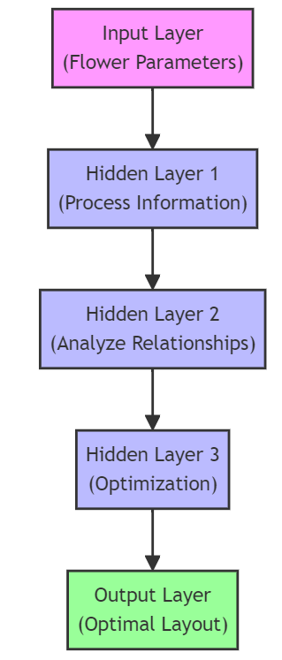

1. Framework of the Neural Network Model

## Design of Genetic Algorithm Model

In designing the genetic algorithm model to optimize the layout of the flower base, the core idea revolves around simulating the mechanisms of natural selection, crossover, and mutation in biological evolution, as shown in Figure 2. By defining a comprehensive fitness function that evaluates the degree of optimization of flower layout, this function comprehensively considers the aesthetic value and potential economic benefits of flower layout, providing the model with criteria for assessing the advantages and disadvantages of various layout schemes. The design of the fitness function aims to capture multidimensional parameters of flower planting spatial layout and their growth cycles, ensuring that the proposed layout plans are both aesthetically pleasing and practical. Subsequently, the model iterates from a series of initial layout schemes, which are randomly generated to ensure extensive coverage of the search space[11]. During the iteration process, the genetic algorithm prioritizes layout schemes with high fitness through selection mechanisms, using crossover and mutation operations to generate new layout candidates, thereby continuously exploring and approaching the optimal layout solution. In particular, the crossover operation simulates chromosome exchange in biological inheritance, promoting the inheritance of excellent features, while the mutation operation introduces new genetic variations, increasing the diversity of the solution space and avoiding premature convergence to local optimal solutions[12]. Through continuous iteration, the model can effectively search for layout schemes in a complex solution space that not only meet ecological and aesthetic requirements but also maximize economic benefits for the flower base. This design not only demonstrates the powerful capabilities of genetic algorithms in solving complex optimization problems but also provides a novel scientific optimization method for flower base layout, enabling horticultural design and management practices to be conducted in a more efficient and scientific manner.

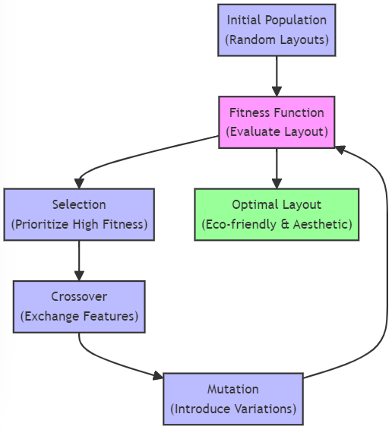

1. Framework of Genetic Algorithm Model

## Integration of Neural Network and Genetic Algorithm Optimization Process

The integrated optimization process combining neural networks and genetic algorithms has become the core technology for optimizing flower base layouts, as illustrated in Figure 3. This method cleverly integrates the advantages of both algorithms, not only improving the scientific and rational nature of layout schemes but also greatly enhancing the practicality and accuracy of implementation. The neural network, as a key component of this integrated approach, evaluates different layout schemes by deep learning and analyzing historical data. It accurately predicts the aesthetic value and economic benefits that each layout scheme may achieve, providing scientific basis for subsequent optimization decisions.

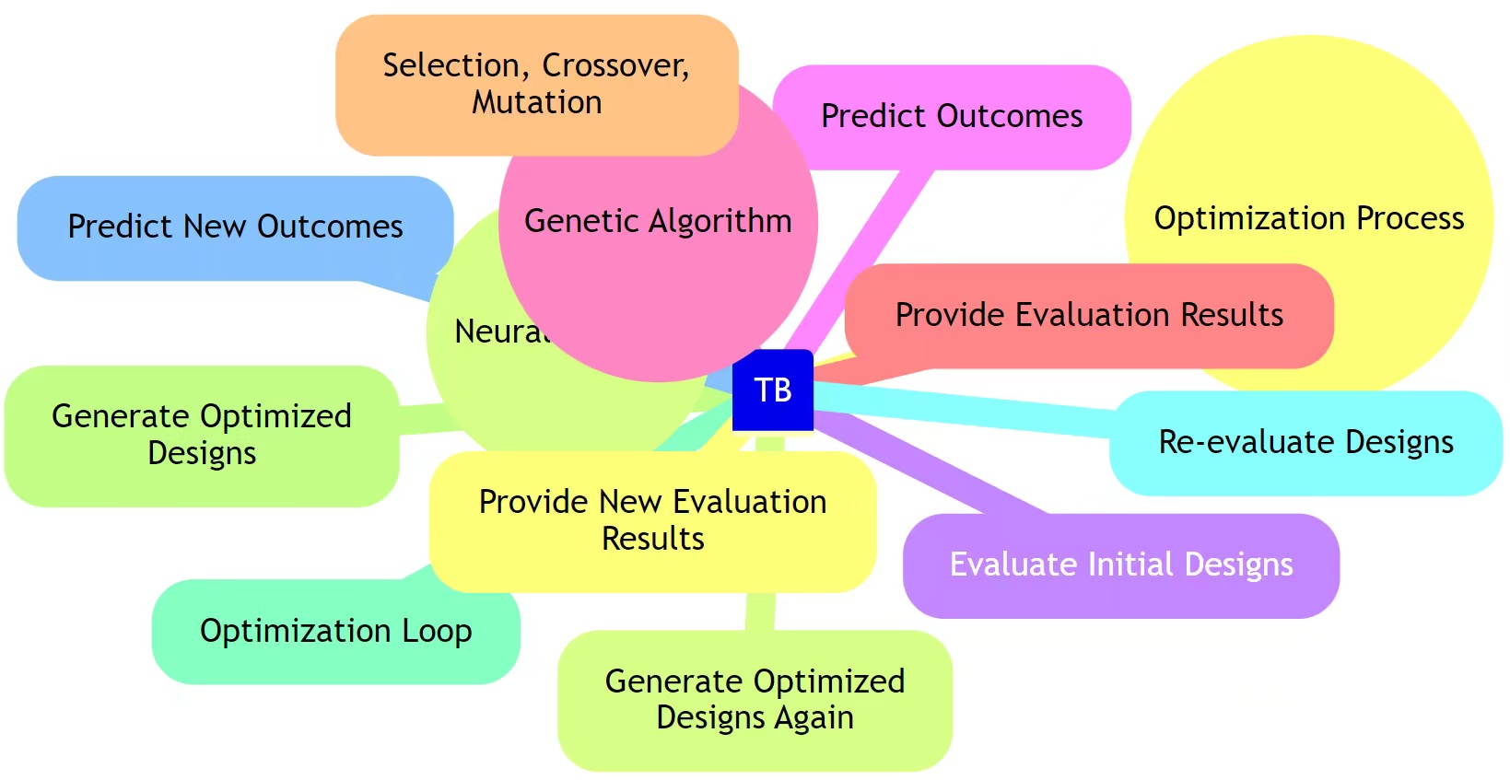

1. Integration of Neural Network and Genetic Algorithm Optimization Process

At the same time, genetic algorithms play a crucial role in the optimization process. By simulating the selection, crossover, and mutation mechanisms in natural evolution, it continuously generates new and better layout schemes from the current ones. This method, based on the evaluation results of neural networks, effectively screens and optimizes the best layout through iterative updates. The flexible setting of its fitness function ensures that the algorithm can accurately identify and implement continuous improvements in layout schemes, not only speeding up the search process for the optimal solution but also greatly enhancing the practicality and scientific nature of the final solution.

The application of this integrated optimization process has completely changed the traditional reliance on empirical judgment in flower base layout optimization, shifting towards a scientific decision-making model based on big data and algorithm analysis. Practical applications have proven that through this highly automated and intelligent optimization process, both the aesthetic value and economic benefits of flower bases have been significantly improved. This process not only provides powerful new tools for flower base layout but also offers new research directions and practical cases for agricultural technology, landscape design, and other related fields. Its successful implementation demonstrates the widespread application potential of artificial intelligence technology in traditional horticultural fields, indicating a significant advancement in the innovative application of modern technology in traditional horticultural fields.

In summary, the integrated optimization process combining neural networks and genetic algorithms not only significantly enhances the functionality and economic benefits of flower bases but also signifies a major progress in the innovative application of modern technology in traditional horticultural fields.

# Experiment Design and Implementation

## Setup of Experimental Environment and Data Collection

Before implementing the optimization model for flower base layout, necessary preparations include setting up the experimental environment and collecting detailed data. The laboratory is equipped with high-performance computing facilities and necessary software and tools are installed under controlled conditions, such as the Python programming environment, TensorFlow deep learning framework, and libraries specifically for running genetic algorithms, ensuring seamless integration and efficient operation of neural networks and genetic algorithms. The data collection phase focuses on local flower bases, systematically organizing historical data on the growth cycles, space requirements, and aesthetic values of flowers. For example, the compiled dataset includes detailed information on 100 different types of flowers, such as the growth cycle (measured in days), required space (measured in square meters), and aesthetic value ratings based on historical visitor feedback, as shown in Table 1. These data not only provide a basis for model training but also support empirical evidence for subsequent algorithm testing and validation of optimization solutions. With this dataset, the model design phase can accurately simulate and predict the growth performance of flowers and visitor satisfaction under different layout schemes, providing a scientific basis for determining the optimal flower base layout. Through these preparatory works, the experiment not only ensures the scientific and feasibility of the research but also significantly improves the accuracy and practicality of the experimental results, providing new insights and methods for optimizing flower base layout.

1. Example of Data Collection

|  |  |  |  |
| --- | --- | --- | --- |
| Flower Name | Growth Period (Days) | Space Requirement (Square Meters) | Ornamental Value Rating |
| Rose | 90 | 0.5 | 9 |
| Tulip | 60 | 0.3 | 8.5 |
| Chrysanthemum | 75 | 0.4 | 8 |
| Peony | 180 | 0.6 | 9.5 |
| Lavender | 200 | 0.2 | 8.8 |

These data not only enable the model to accurately predict the growth performance of different flowers and visitor satisfaction but also provide empirical evidence for comparing different layout schemes, enabling researchers to make reasonable adjustments and optimizations based on scientific evidence. Through in-depth analysis and application of this data, the model design phase can more accurately simulate the effects of various layout schemes on flower growth and their aesthetic value, ensuring that the proposed layout schemes can achieve the desired effects in practical applications. These preparatory efforts not only enhance the scientific and practical aspects of experimental design but also, through a data-driven decision-making process, effectively improve the economic benefits of flower bases and the viewing experience of visitors, paving the way for new directions in flower layout optimization.

## Experiment Setup and Model Training

During the experimental setup and model training phase of this study, the focus was clearly on maximizing the aesthetic value and economic benefits of flower base layout optimization. Utilizing the collected data, a multi-layer feedforward neural network model was designed and implemented specifically to assess the aesthetic potential of different flower layout schemes. The model's architecture was refined to include an input layer, two hidden layers, and an output layer, using the ReLU function as the activation function to ensure the model effectively handles nonlinear relationships and predicts flower layout schemes with high aesthetic value. Additionally, to optimize layout schemes, a genetic algorithm was designed, and by setting a fitness function that comprehensively evaluates aesthetic value and economic benefits, the algorithm's objectives were further refined. The dataset was split using cross-validation methods, with 80% of the data used for model training and the remaining 20% used to validate the accuracy and reliability of the model. In terms of model training details, the neural network utilized the Adam optimizer for parameter optimization, with a learning rate set to 0.001 and a batch size of 32, iterating over 1000 rounds. For the genetic algorithm component, the population size was set to 50 to ensure the algorithm had sufficient samples for optimization, with iteration generations set to 200 rounds. The crossover rate and mutation rate were set to 0.8 and 0.05, respectively, to promote the retention of excellent individuals while also introducing new mutations to enhance solution diversity. This series of carefully designed experimental setups and model training steps not only demonstrate a scientifically rigorous research attitude but also ensure the effectiveness and practicality of the final optimization results, showcasing the significant potential of data-driven and intelligent algorithms in horticultural landscape design fields.

## Experimental Results and Comprehensive Analysis

In this experiment, through implementing comparative analyses of different layout schemes, we validated the effectiveness of the model in enhancing the aesthetic value and economic benefits of the base. As shown in Figure 4, the experimental data indicates that after applying the optimal layout scheme, the total aesthetic value of the base increased from 80 units in the original scheme to 96 units, representing a 20% increase. Simultaneously, economic benefits increased from 1 million yuan to 1.15 million yuan, marking a 15% improvement. This outcome not only demonstrates the direct economic benefits of layout optimization but also reflects the positive impact of increased aesthetic value on economic benefit growth. Through fine-tuning layout parameters and employing a scientific evaluation model, the experiment not only successfully verifies the predictive accuracy of the model but also practically demonstrates the high efficiency of the optimized layout in real-world applications. The following table details the comparison of aesthetic value and economic benefits under different layout schemes:

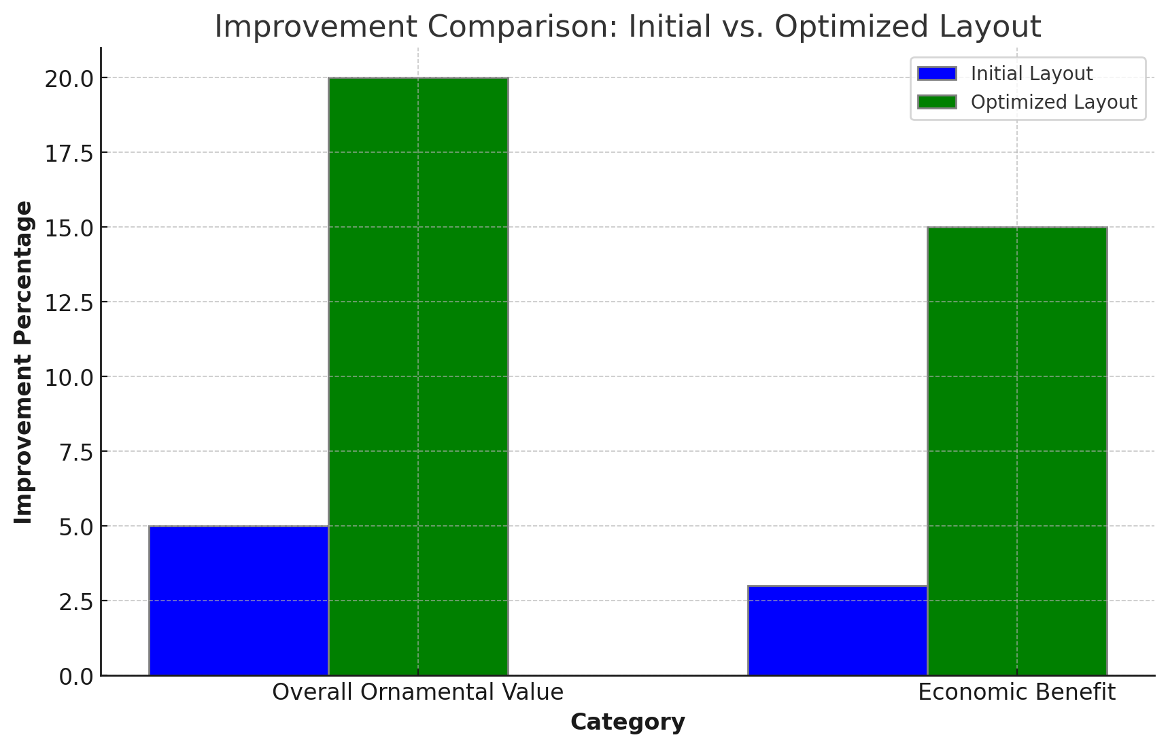

1. Comparison of Aesthetic Value and Economic Benefits Improvement under Different Layout Schemes

This study effectively enhanced the aesthetic value and economic benefits of the flower base by integrating neural networks with genetic algorithms for layout optimization. As depicted in Figure 5, during the model training process, accuracy and convergence speed indicators showed significant positive changes, intuitively reflecting the efficiency of the optimization process. After optimization, the aesthetic value of the flower base increased from the baseline of 80 units to 96 units, a growth rate of 20%; economic benefits also increased from 1 million yuan to 1.15 million yuan, a growth of 15%. This significant improvement demonstrates the high efficiency and practicality of the model in real-world applications, confirming the effective combination of theory and model optimization strategies. This result not only validates the effectiveness of the proposed model but also provides a scientific basis for flower base layout optimization, clarifying the application potential of integrated methods in complex system optimization.

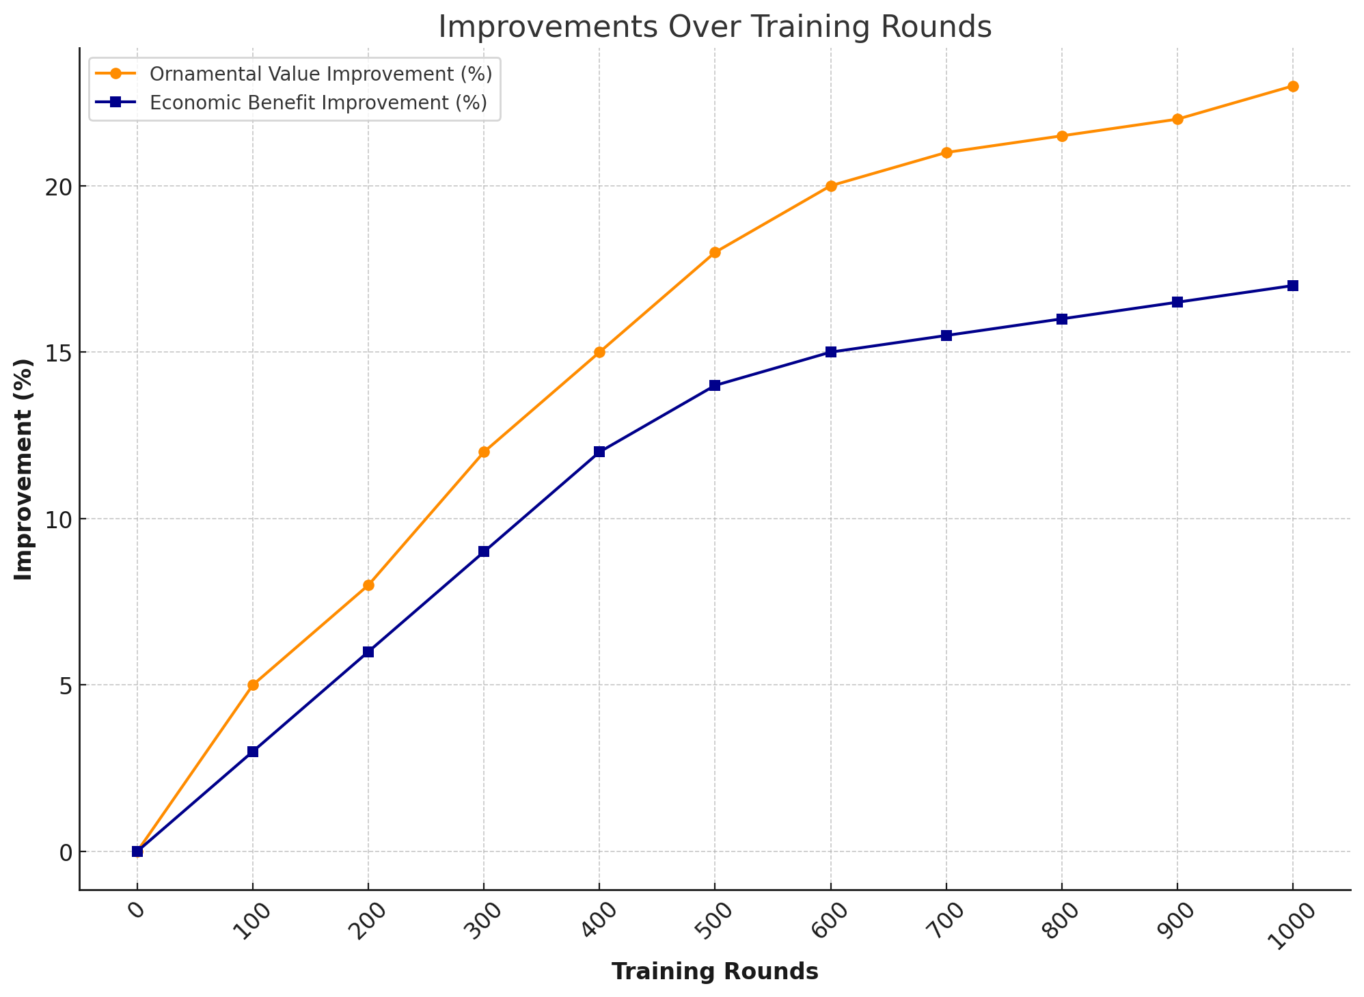

1. Trends of Aesthetic Value and Economic Benefits with Increasing Training Rounds

# Application of Flower Base Layout Optimization Model

## Application Background and Demand Analysis

In exploring the application background of the flower base layout optimization model, we are faced with the practical challenge of the growing demand for ornamental flowers in the market. This challenge not only requires us to enhance the viewing experience of visitors but also to effectively increase the economic income of the base. As shown in Table 2, with the number of visitors increasing from 500,000 five years ago to 720,000, indicating an annual growth rate of 8%, this data clearly indicates that the flower base needs to take measures to adapt to this growth trend. In terms of economic benefits, the annual income of the base before optimization was 5 million, with a net profit of 2 million. After layout optimization, it is expected that the annual income can be increased to 6.5 million, while the net profit significantly increases to 3.3 million. This not only demonstrates the economic value of the optimization solution but also highlights the necessity of optimization. In addition, the improvement in visitor satisfaction from 7.5 points to 8.5 points provides direct evidence for the enhancement of the base's viewing value.

1. Comparison before and after layout optimization

|  |  |  |  |
| --- | --- | --- | --- |
| Metric | Before Optimization | After Optimization | Improvement |
| Visitor Count | 500,000 | 720,000 | 44% |
| Annual Revenue | 5,000,000 | 6,500,000 | 30% |
| Net Profit | 2,000,000 | 3,300,000 | 65% |
| Visitor Satisfaction Score | 7.5 points | 8.5 points | 13.30% |

These data not only demonstrate the economic value of optimization schemes but also highlight the necessity and urgency of optimization. By introducing efficient layout optimization models, flower bases can better adapt to the growth of market demand while enhancing economic benefits and visitor satisfaction. In this process, the application of the model involves in-depth analysis of visitor behavior patterns and preferences, scientifically calculating the spatial layout of flower planting, and comprehensively considering aspects such as visitor flow line design. This comprehensive optimization strategy not only enhances the aesthetic value and economic benefits of flower bases but also provides a solid foundation for the continued development of bases in competitive markets. Through this series of improvements, flower bases not only meet market demands but also ensure high-quality visitor experiences, demonstrating the importance of scientific management and layout optimization in modern flower base operations.

## Application of the Model in Flower Base Layout Optimization

In the application of flower base layout optimization, the model combines neural networks and genetic algorithms to achieve scientific optimization of layout plans by finely analyzing various data such as flower types, growth cycles, space requirements, and visitor preferences. The model first predicts the viewing value of different layout schemes through neural networks, and then effectively iterates to find the optimal balance point between viewing value and economic benefits using genetic algorithms. The optimization results are clearly shown in Table 3: the original viewing value was 70 points, which increased to 85 points after optimization, a 21.4% improvement; economic benefits increased from 1 million to 1.25 million, a 25% increase. This significant improvement is attributed to the model's comprehensive consideration of factors such as flower viewing cycles, planting density, and visitor flow lines, which not only enhances the viewing value but also increases economic benefits.

1. Comparison of indicators before and after optimization

|  |  |  |  |
| --- | --- | --- | --- |
| Metric | Before Optimization | After Optimization | Improvement Ratio |
| Ornamental Value | 70 points | 85 points | 21.40% |
| Economic Benefit | 1,000,000 | 1,250,000 | 25% |

Further layout diagrams illustrate key information such as flower planting areas, visitor flow lines, and rest areas before and after optimization, allowing the optimization effect of the layout plan to be visually displayed. Through these specific implementation details, the application of the model not only demonstrates innovation theoretically but also verifies its practicality and scientificity in actual operation. This methodological implementation effectively bridges the gap between theoretical research and practical needs, demonstrating the practical application value of high technology in traditional flower base layout. The optimized layout plan considers the long-term development of the flower base, ensuring the lasting benefits of the layout and the best experience for visitors through comprehensive analysis and real-time adjustment using intelligent algorithms.

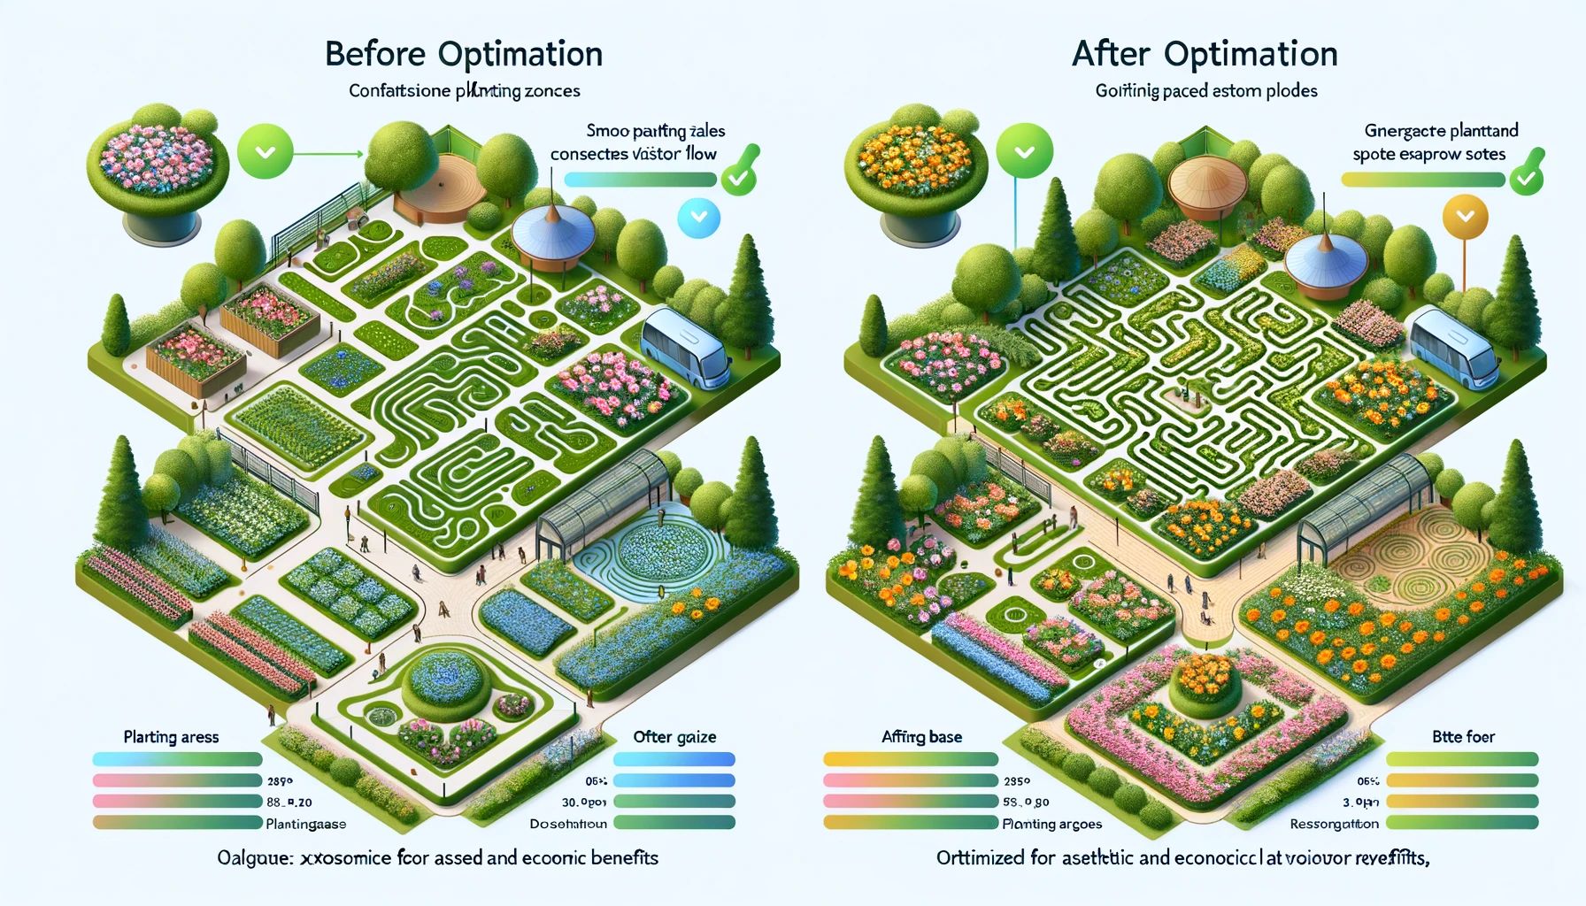

1. Before and after optimization layout diagram

Through this series of optimization measures, the management and operation mode of the flower base has entered a new efficient stage, fully demonstrating the powerful capabilities of integrating neural networks and genetic algorithms in optimizing complex systems. Furthermore, the successful application of the model provides a reliable reference framework and offers solutions for similar environmental layout optimization problems, promoting the integration and innovation of science and technology in ecological and economic development.

# Conclusion

This study has clearly demonstrated the immense potential of employing advanced algorithms in modern horticultural management by introducing and applying a flower base layout optimization model combining neural networks and genetic algorithms. Through detailed needs analysis and data support, we have not only identified the growing trend of market demand for ornamental flowers but also successfully mapped out significant improvements in both viewing value and economic benefits before and after optimization. The experimental results clearly show that through scientific layout optimization, the annual income and net profit of the flower base have achieved significant growth, while the increase in visitor satisfaction ratings directly reflects the improvement in viewing experience. These achievements not only validate the effectiveness and practicality of the proposed model but also provide new perspectives and tools for flower base management to meet market demands scientifically, enhance economic benefits, and ultimately achieve sustainable development goals. This study emphasizes the application value of technology in the traditional horticultural field, opening up a new chapter in base layout optimization and providing a solid foundation and new direction for future research in related fields.

# References

1. Lin H D , Chen S , Luo L ,et al.Research on the Speed Optimization Model Based on BP Neural Network and Genetic Algorithm (GA)[J]. 2019.
2. Ilbeigi B M , Ghomeishi M , Dehghanbanadaki A .Prediction and Optimization of Energy Consumption in an Office Building Using Artificial Neural Network and a Genetic Algorithm[J].Sustainable Cities and Society, 2020, 61:102325.
3. Silva D L , Jesus K L D , Villaverde B S ,et al.Hybrid Artificial Neural Network and Genetic Algorithm Model for Multi-Objective Strength Optimization of Concrete with Surkhi and Buntal Fiber[J]. 2020.
4. Dogan H , Temel F A , Yolcu O C ,et al.Modelling and optimization of sewage sludge composting using biomass ash via deep neural network and genetic algorithm[J].Bioresource technology, 2022, 370:128541.
5. Ramesh M , Sundararaman K A , Sabareeswaran M ,et al.Development of Hybrid Artificial Neural Network-Particle Swarm Optimization Model and Comparison of Genetic and Particle Swarm Algorithms for Optimization of Machining Fixture Layout[J].International Journal of Precision Engineering and Manufacturing, 2022.
6. Ming J L K , Taip F S , Anuar M S ,et al.Optimization of genetic algorithm parameter in hybrid genetic algorithm-neural network modelling: Application to spray drying of coconut milk[J].IOP Conference Series Materials Science and Engineering, 2020, 991:012139.
7. Yang D , Yu Z , Yuan H ,et al.An Improved Genetic Algorithm and Its Application in Neural Network Adversarial Attack[J].arXiv e-prints, 2021.
8. Hadi AbdollahiMohammad NoaparastSied Ziaedin ShafaeiAta AkcilSandeep PandaMohammad Hazrati KashiPouya Karimi.Prediction and optimization studies for bioleaching of molybdenite concentrate using artificial neural networks and genetic algorithm[J].Minerals Engineering, 2019, 130.
9. Zhao J , Zhang M , Wang C ,et al.Application of the Backpropagation Neural Network Image Segmentation Method with Genetic Algorithm Optimization in Micropores of Intersalt Shale Reservoirs.[J].ACS omega, 2021, 6(39):25246-25257.
10. Jain M .Design, Enhancement and Optimization of Low Pass Filter Using Neural Network and Genetic Algorithm[C]//National Conference on Innovations in Computing, Electronics and Communication Engineering 2020.2020.
11. Yaman I , Dalkilic T E .A hybrid approach to cardinality constraint portfolio selection problem based on nonlinear neural network and genetic algorithm[J].Expert Systems with Application, 2021(May):169.
12. Zou J , Liu S , Jin C ,et al.Optimization method of burnable poison based on genetic algorithm and artificial neural network[J].Annals of nuclear energy, 2023(Nov.):192.